SIMATS ENGINEERING
ASSESSMENT TOOL 2
COURSE NAME: CSA07 COURSE CODE: Computer Networks

COURSE OUTCOME COVERED
CO1: Apply the functions of OSI layer in enabling reliable data transmission across networks.
(BL2, BL3)
Assessment Tool Weightage: 30%
Annexure A

CONCEPT MAPPING
- A partially completed concept map is given below:
Application → Presentation → ______ → Transport → Network → ______ → Physical.
Analyze the missing layers and explain how their functions are essential for reliable
communication.

Missing Layers:
Session Layer
Establishes, manages, and terminates communication sessions.
Provides synchronization between devices.
Data Link Layer
Performs framing, MAC addressing, and error detection.
Ensures reliable node-to-node data transfer.
Importance for Reliable Communication:
Session layer maintains communication between applications.
Data Link layer detects transmission errors and delivers frames correctly.
Together they improve reliability and efficiency.
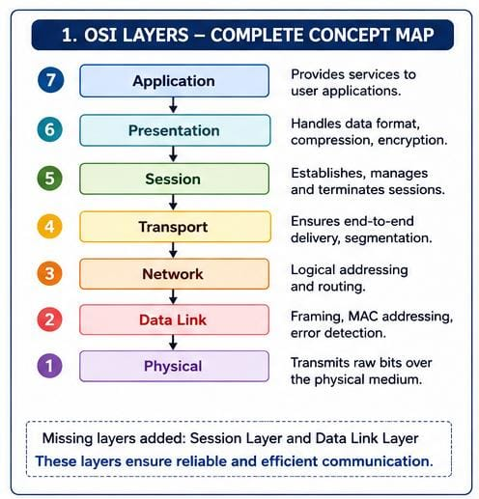

- Construct a concept map linking data units (Segment, Packet, Frame, Bits) with their respective OSI layers and analyze how transformation of data units supports transmission.
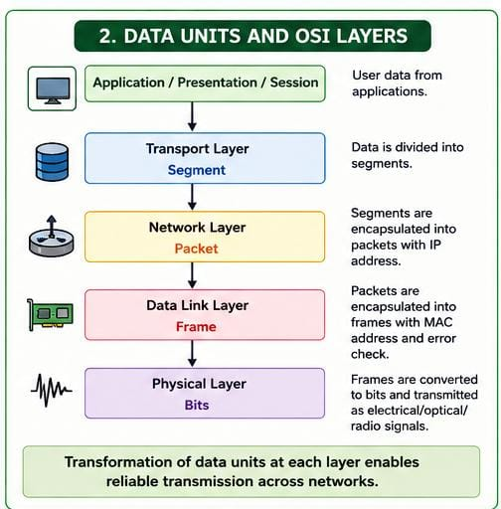

Analysis:
Segment: Transport layer divides data.
Packet: Network layer adds IP address for routing.
Frame: Data Link layer adds MAC address and error detection.
Bits: Physical layer converts data into electrical/optical/radio signals.
This transformation allows efficient and reliable transmission over networks.

3.Given the concept map:
Data Link→ MAC Address→ Local Delivery
Network → IP Address → Global Delivery
Explain how these relationships ensure complete data delivery across networks.
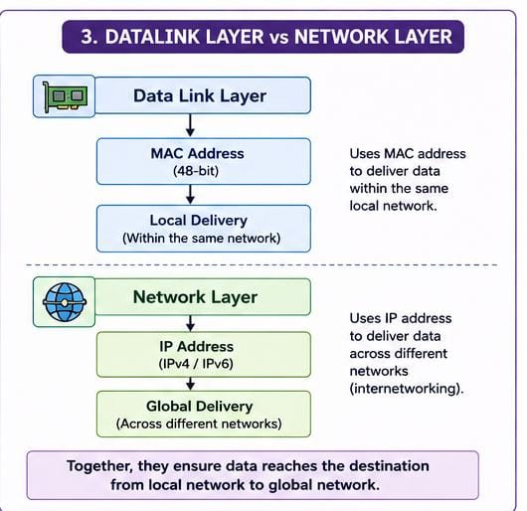
Explanation:
Data Link layer uses MAC addresses to deliver data within the same local network. Network layer uses IP addresses to deliver packets between different networks. Together they ensure complete end-to-end communication.
4.A concept map shows:
Error Control
→DataLinkLayer→ErrorDetection
→ Transport Layer → Error Correction
Analyze how the interaction between these layers improves reliability in data transmission.

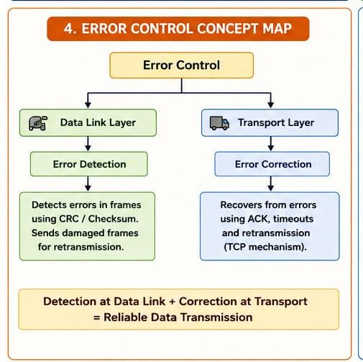

Analysis:
Data Link layer detects transmission errors using CRC or checksum.
Transport layer (TCP) corrects errors through acknowledgements and retransmissions. Their combined operation ensures accurate and reliable data delivery.

5.Develop a concept map for web browsing using OSI layers and analyze how failure in
one layer affects the entire communication process.
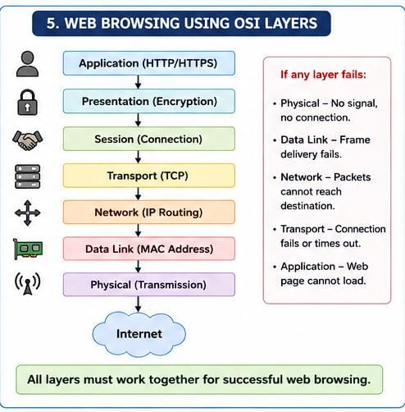

Analysis:
If any OSI layer fails, communication is interrupted.
Example:
Physical layer failure → No connection.
Network layer failure → Packets cannot reach destination.
Transport layer failure → Connection times out.
Application layer failure → Web page cannot load.

6.A network issue is represented in the concept map:
Physical ✔ → Data Link ✔ → Network ✖ → Transport ✖ → Application ✖
Analyze the problem and explain how the concept map helps in troubleshooting.
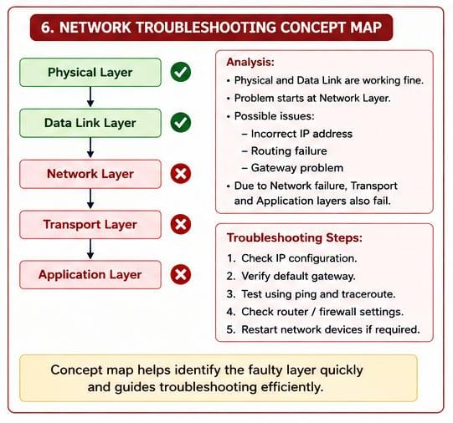

Analysis:
Physical and Data Link layers are working correctly.
The problem starts at the Network layer, likely due to:
Incorrect IP address
Routing failure
Gateway problem
Since the Network layer fails, Transport and Application layers also fail.
Troubleshooting Steps:
1. Check IP configuration.
2. Verify default gateway.
3. Test using ping and traceroute.
4. Check router configuration.
5. Restart network devices if required.

RUBRICS FOR CALCULATION
Criteria | Weightage (%) | Level 4 (Exemplary) | Level 3 (Proficient) | Level 2 (Developing) | Level 1 (Beginning)
Concept Identification | 20% | Accurately  identifies all  relevant OSI layers, concepts, and relationships | Identifies most concepts with minor omissions | Identifies limited  concepts; some  inaccuracies | Unable to identify key  concepts correctly
Concept  Mapping  Structure | 25% | Constructs a clear, logical, and well-  organized concept  map with proper  hierarchy and connections | Concept map is mostly clear with  minor structural issues | Concept map lacks clarity,  organization, or proper flow | No clear structure or  incorrect mapping
Linking & Relationships | 20% | Clearly establishes correct  relationships  between layers,  functions, and processes | Relationships are mostly correct with minor errors | Limited or partially correct  relationships | Incorrect or missing relationships
Application & Analysis | 20% | Effectively applies concepts to explain processes (e.g.,  encapsulation, error control) with strong reasoning | The application is correct but lacks  depth in analysis | Basic  application with weak explanation | Unable to apply concepts correctly
Explanation & Clarity | 15% | Provides a clear, concise, and wellstructured  explanation  supporting the concept map | Explanation is understandable with minor gaps | Explanation is unclear or incomplete | No clear or meaningful explanation

